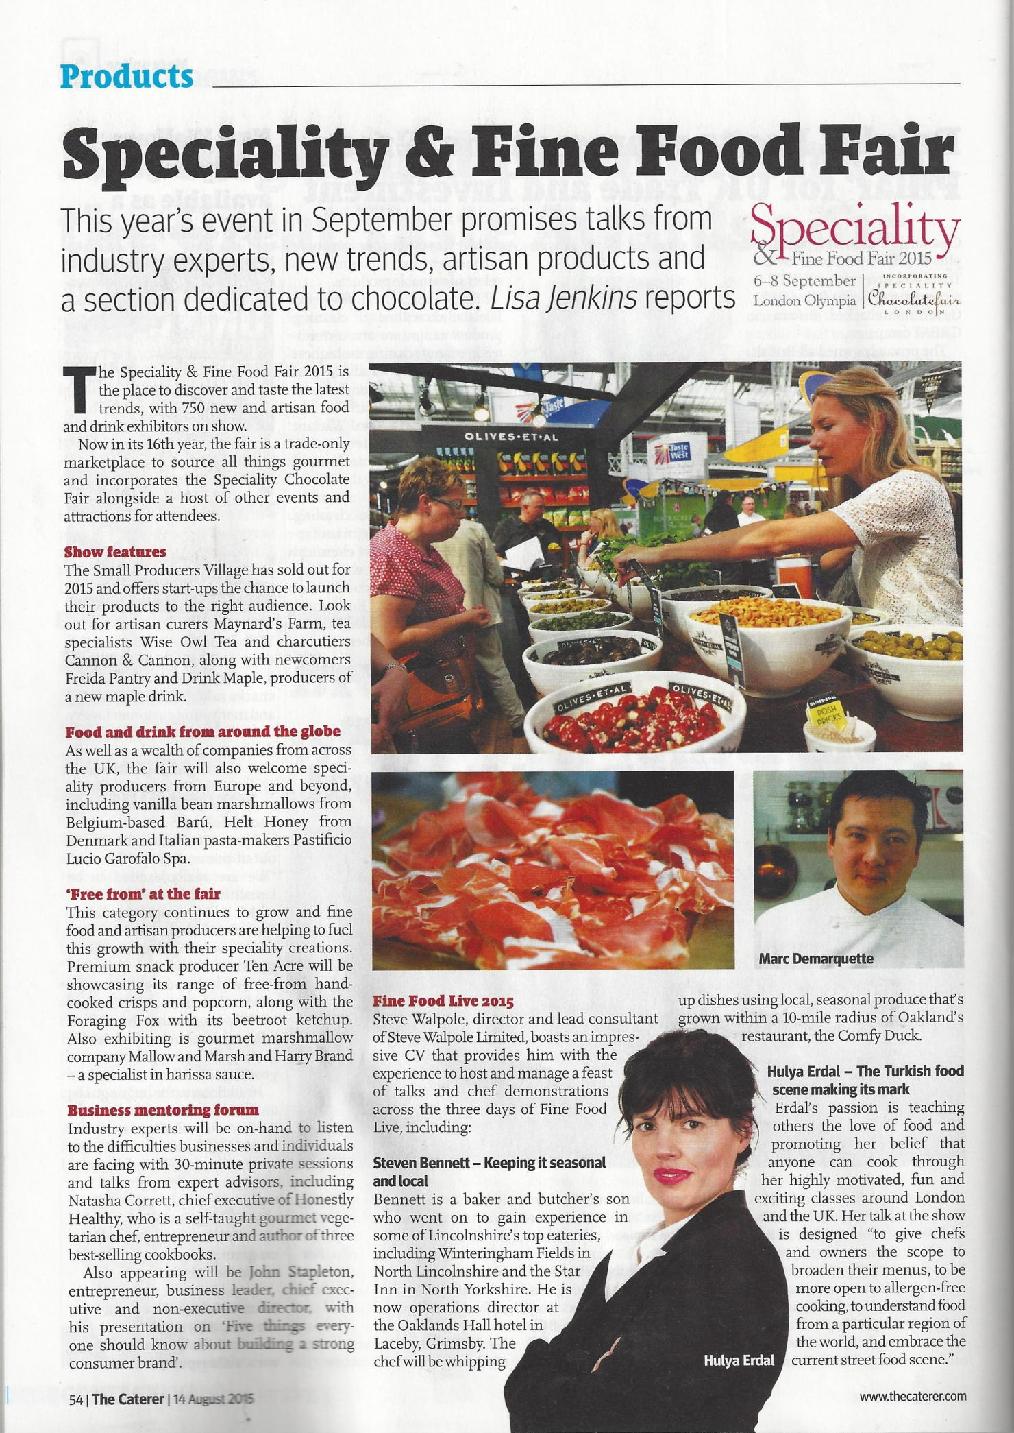
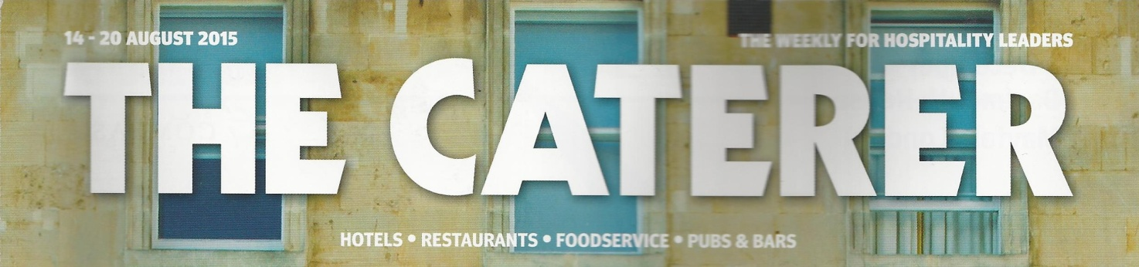
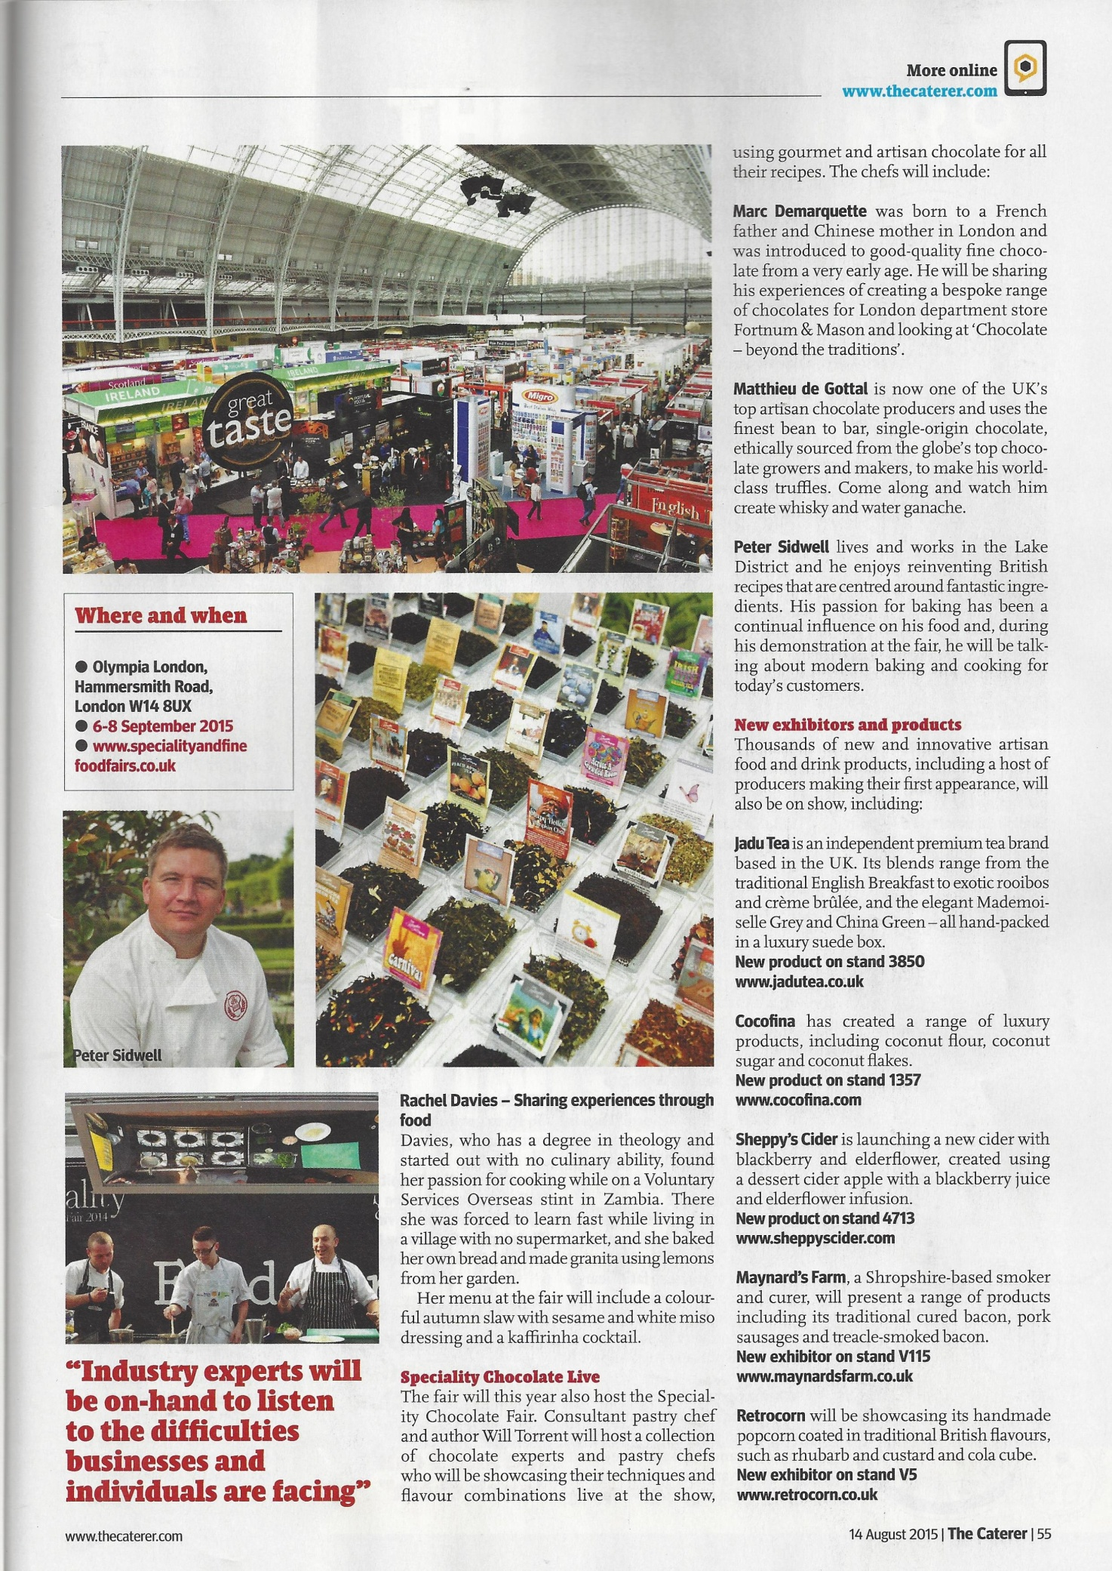

Name | The Caterer
Media Type | Magazine
Circulation | 8000
Readership figures: | 33,000 readers per week
Online | 220,000 unique users per month, 600,000 page impressions
Audience/Readership: | Professionals in the catering and hospitality industry
Date: | 14 - 20th August 2015

